Step-by-Step Guide to Creating a Backend API with ASP.NET Core

Step 1: Setup Project

1. Install .NET SDK and PostgreSQL:
- Download and install .NET SDK from dotnet.microsoft.com.
- Install PostgreSQL from postgresql.org.

2. Create ASP.NET Core Project:
```bash
dotnet new webapi -o db_siswa_api
cd db_siswa_api
```

3. Add NuGet Packages:
```bash
dotnet add package Npgsql.EntityFrameworkCore.PostgreSQL
dotnet add package Microsoft.EntityFrameworkCore.Design
```

Step 2: Configure Database and Model

1. Create Siswa Model:
Create `Models/Siswa.cs`:
```csharp
using System.ComponentModel.DataAnnotations;
using System.ComponentModel.DataAnnotations.Schema;

namespace db_siswa_api.Models
{
public class Siswa
{
[Key]
[DatabaseGenerated(DatabaseGeneratedOption.Identity)]
public int Id { get; set; }

[Required]
public string Nama { get; set; } = string.Empty;

[Required]
public int Umur { get; set; }

[Required]
public string Kelas { get; set; } = string.Empty;
}
}
```

2. Create Database Context:
Create `Models/SiswaContext.cs`:
```csharp
using Microsoft.EntityFrameworkCore;

namespace db_siswa_api.Models
{
public class SiswaContext : DbContext
{
public SiswaContext(DbContextOptions<SiswaContext> options) : base(options) { }

public DbSet<Siswa> Siswa { get; set; }
}
}
```

3. Configure Connection String:
Update `appsettings.json`:
```json
{
"ConnectionStrings": {
"DefaultConnection": "Host=localhost;Database=db_siswa;Username=postgres;Password=yourpassword"
}
}
```

4. Register Context in `Program.cs`:
```csharp
using db_siswa_api.Models;
using Microsoft.EntityFrameworkCore;

var builder = WebApplication.CreateBuilder(args);

builder.Services.AddControllers();
builder.Services.AddDbContext<SiswaContext>(options =>
options.UseNpgsql(builder.Configuration.GetConnectionString("DefaultConnection")));

var app = builder.Build();

app.UseAuthorization();

app.MapControllers();

app.Run();
```

Step 3: Create Siswa Controller

1. Create `Controllers/SiswaController.cs`:
```csharp
using Microsoft.AspNetCore.Mvc;
using Microsoft.EntityFrameworkCore;
using db_siswa_api.Models;
using System.Threading.Tasks;
using System.Linq;

namespace db_siswa_api.Controllers
{
[Route("api/[controller]")]
[ApiController]
public class SiswaController : ControllerBase
{
private readonly SiswaContext _context;

public SiswaController(SiswaContext context)
{
_context = context;
}

// GET: api/Siswa/5
[HttpGet("{id}")]
public async Task<ActionResult<Siswa>> GetSiswa(int id)
{
var siswa = await _context.Siswa.FindAsync(id);

if (siswa == null)
{
return NotFound();
}

return siswa;
}

// POST: api/Siswa
[HttpPost]
public async Task<ActionResult<Siswa>> PostSiswa(Siswa siswa)
{
_context.Siswa.Add(siswa);
await _context.SaveChangesAsync();

return CreatedAtAction(nameof(GetSiswa), new { id = siswa.Id }, siswa);
}

// PUT: api/Siswa/5
[HttpPut("{id}")]
public async Task<IActionResult> PutSiswa(int id, Siswa siswa)
{
if (id != siswa.Id)
{
return BadRequest();
}

_context.Entry(siswa).State = EntityState.Modified;

try
{
await _context.SaveChangesAsync();
}
catch (DbUpdateConcurrencyException)
{
if (!SiswaExists(id))
{
return NotFound();
}
else
{
throw;
}
}

return NoContent();
}

// DELETE: api/Siswa/5
[HttpDelete("{id}")]
public async Task<IActionResult> DeleteSiswa(int id)
{
var siswa = await _context.Siswa.FindAsync(id);
if (siswa == null)
{
return NotFound();
}

_context.Siswa.Remove(siswa);
await _context.SaveChangesAsync();

return NoContent();
}

private bool SiswaExists(int id)
{
return _context.Siswa.Any(e => e.Id == id);
}
}
}
```

Step 4: Migrate and Update Database

1. Add Migration:
```bash
dotnet ef migrations add InitialCreate
```

2. Update Database:
```bash
dotnet ef database update
```

Step 5: Test API using Postman

#### GET by ID
1. **URL**: `GET http://localhost:5000/api/siswa/1`
2. **Description**: Get the student data with ID = 1.

#### POST
1. **URL**: `POST http://localhost:5000/api/siswa`
2. **Body** (JSON):
```json
{
"nama": "John Doe",
"umur": 15,
"kelas": "10A"
}
```

#### PUT by ID
1. **URL**: `PUT http://localhost:5000/api/siswa/1`
2. **Body** (JSON):
```json
{
"id": 1,
"nama": "John Doe Updated",
"umur": 16,
"kelas": "11B"
}
```

#### DELETE by ID
1. **URL**: `DELETE http://localhost:5000/api/siswa/1`
2. **Description**: Delete the student data with ID = 1.

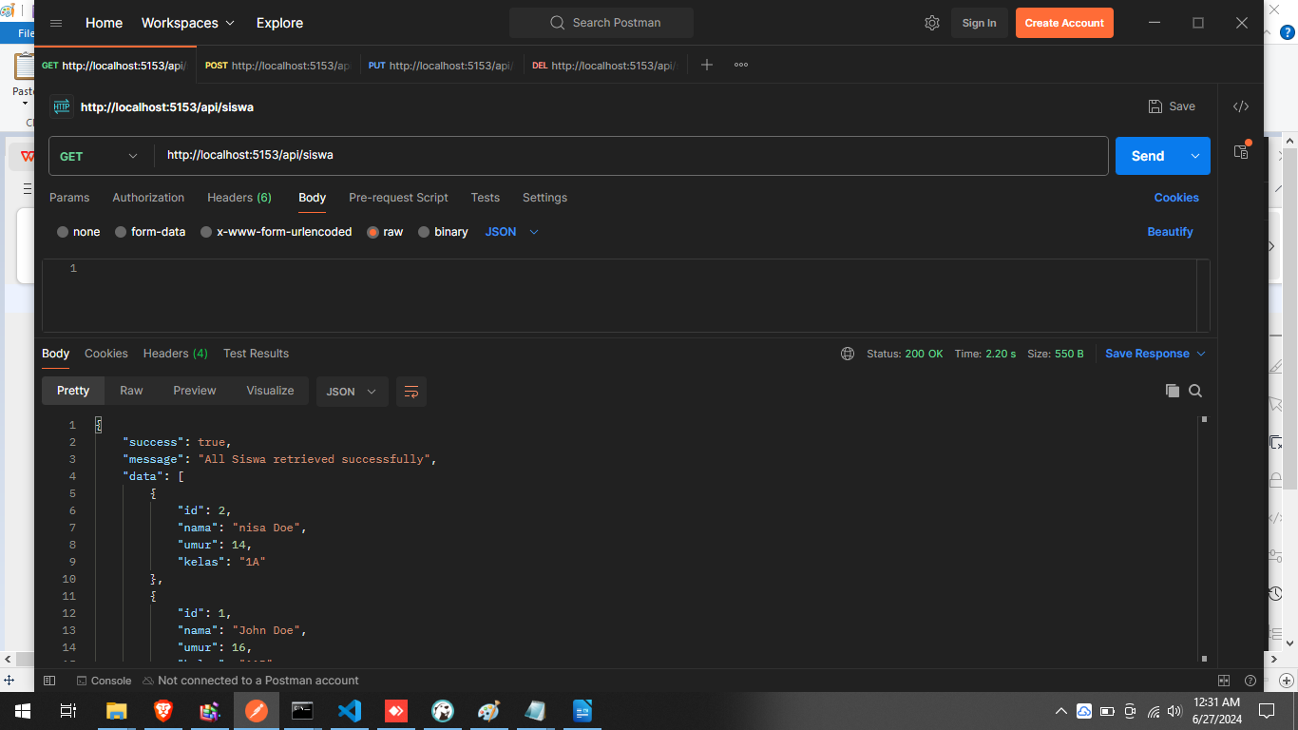
diatas contoh sukses get

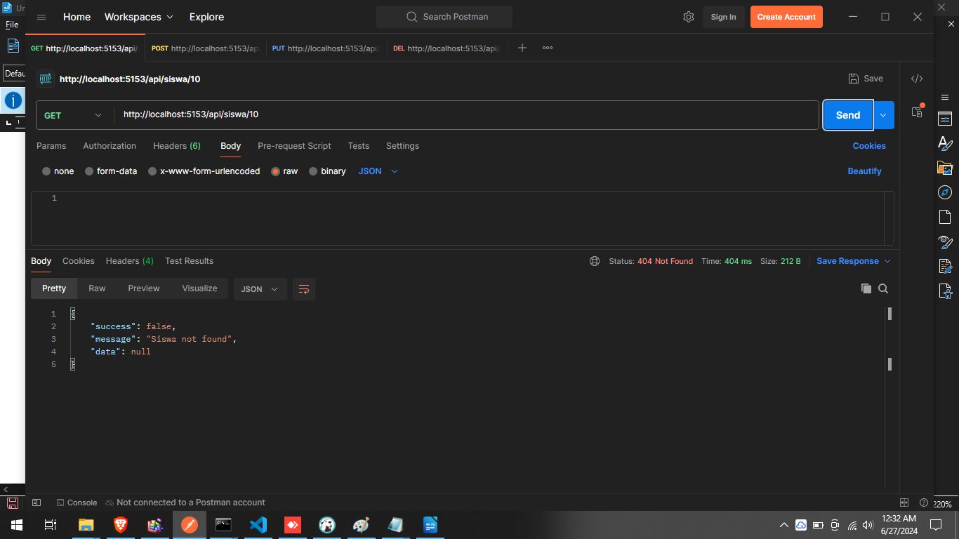
diatas contoh false,karena tidak ditemukan id yg di cari
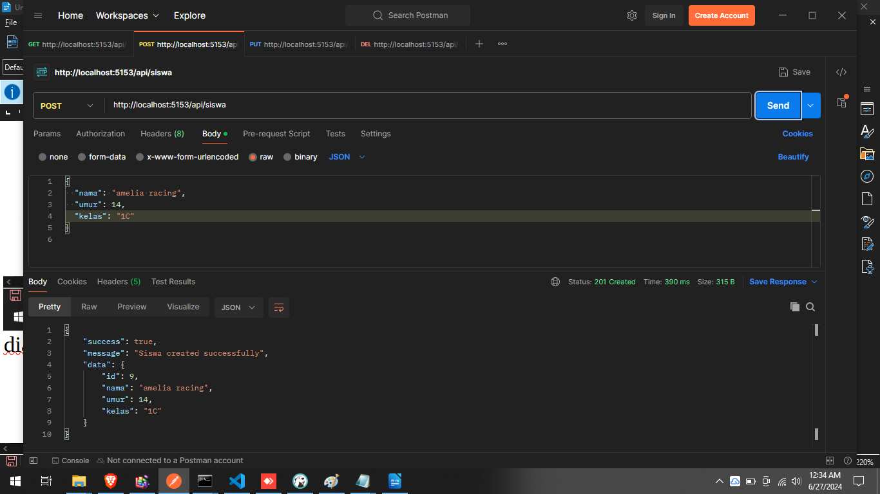
penambahan pada DB dgn tmabahan body

